Approximate Numbers (Numerical Quantifiers)

🔢 What Are Approximate Numbers (Numerical Quantifiers)?
# Source: AI Source: Provided by: [Data Path: Persons Table -> ID Column: 1, Name_En Column: Motasem Essam] -> From: [ChatGPT] on [7/28/2025]
Approximate number quantifiers express an estimated or rough quantity rather than an exact number.
They are used when the exact amount is unknown, unimportant, or unnecessary.

✅ Common Approximate Number Quantifiers:
# Source: AI Source: Provided by: [Data Path: Persons Table -> ID Column: 1, Name_En Column: Motasem Essam] -> From: [ChatGPT] on [7/28/2025]
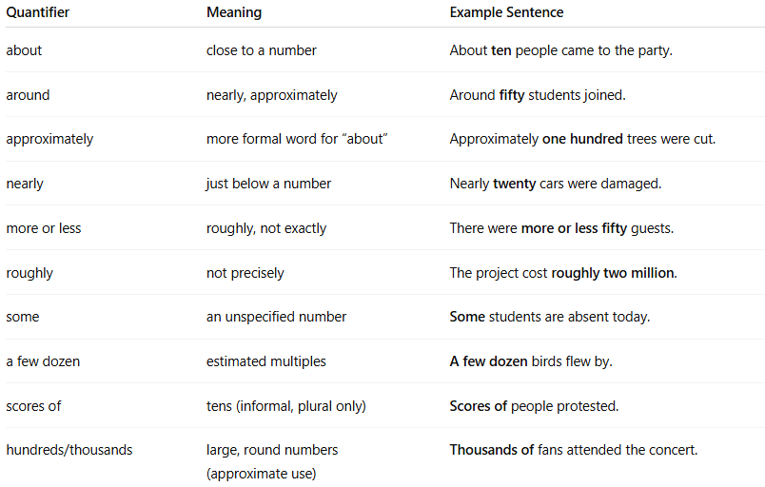
Quantifier | Meaning | Example Sentence
about | close to a number | About ten people came to the party.
around | nearly, approximately | Around fifty students joined.
approximately | more formal word for “about” | Approximately one hundred trees were cut.
nearly | just below a number | Nearly twenty cars were damaged.
more or less | roughly, not exactly | There were more or less fifty guests.
roughly | not precisely | The project cost roughly two million.
some | an unspecified number | Some students are absent today.
a few dozen | estimated multiples | A few dozen birds flew by.
scores of | tens (informal, plural only) | Scores of people protested.
hundreds/thousands | large, round numbers (approximate use) | Thousands of fans attended the concert.

📌 Usage Tips:
# Source: AI Source: Provided by: [Data Path: Persons Table -> ID Column: 1, Name_En Column: Motasem Essam] -> From: [ChatGPT] on [7/28/2025]
- Use with countable/uncountable nouns depending on context.
  - About twenty books (countable)
  - Roughly ten liters of water (uncountable)
- Often used in speech, informal writing, and scientific reports when precision isn't needed.

